BHARATI VIDYAPEETH’S COLLEGE OF ENGINEERING FOR WOMEN

FDP ON

“RESEARCH OPPORTUNITIES IN SUSTAINABLE DEVELOPMENT USING GIS TECHNOLOGIES”

SPONSORED BY AICTE TRAINING AND LEARNING (ATAL) ACADEMY

11 NOVEMBER 2024

Report on Industry Visit

Location: Maharashtra Remote Sensing Application Centre, Pune.

Resource Person: Dr.Sanjay Patil
Sr. Scientist,MASAC, Pune
Date: 14/11/2024
Dr. Sanjay Patil passionately detailed the GIS and remote sensing process, making the session highly productive. MRSAC collaborates closely with the Planning Department, Government of Maharashtra, and has expanded its operations by establishing centers in Mumbai (2013) and Pune (2014) to ensure seamless project execution and timely decision-making. It actively conducts soft skills training and capacity-building programs for government officials, administrators, NGOs, and university students. Leveraging advanced technologies and an extensive digital database across various themes, MRSAC is committed to empowering the state with scientific solutions. Recognized as a leader in Natural Resource Monitoring and GIS, MRSAC continues to drive transparent, efficient, and e-governed initiatives for Maharashtra's progress.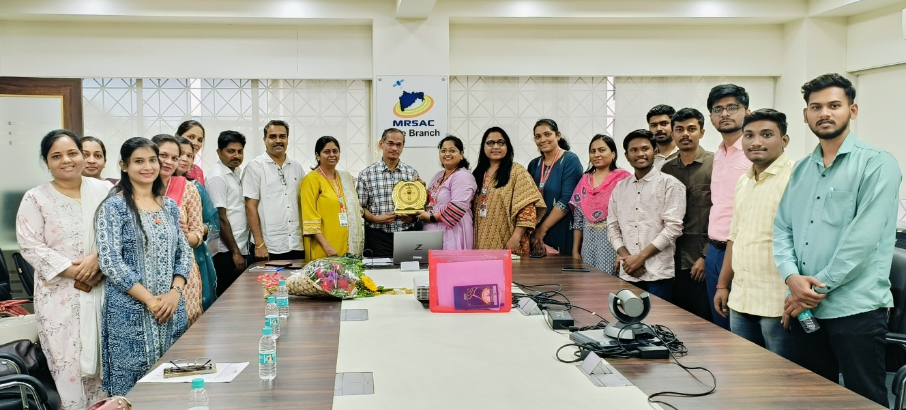
Photo: Industry Visit at MASAC,Pune.
Prepared By
Dr. Makarand Mohan Jadhav

